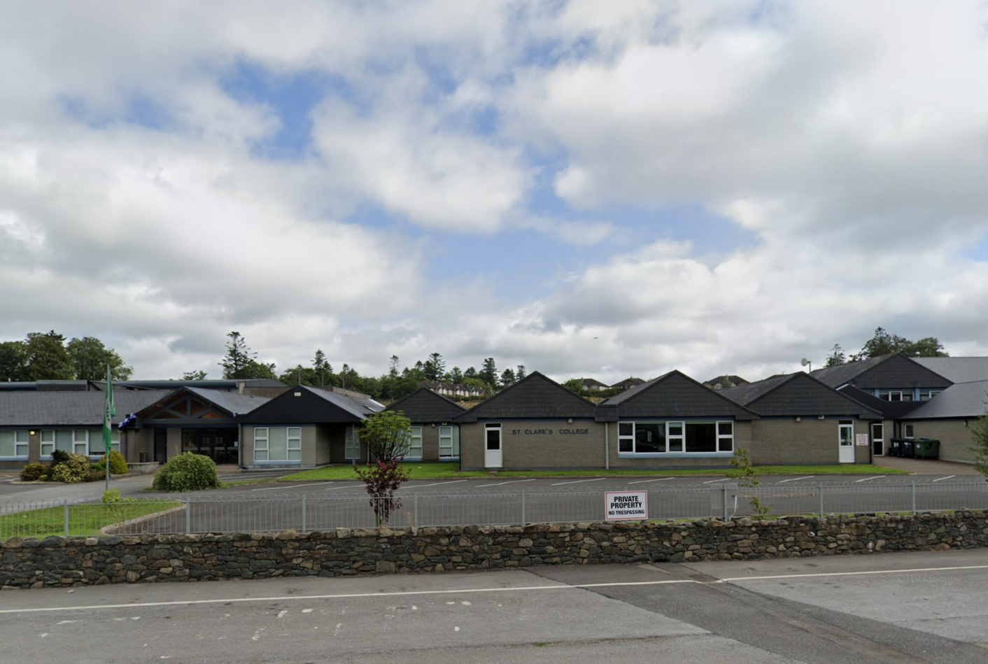
St. Clare’s College is a diocesan co- educational secondary school.
This notion of service is embodied in our mission statement, “to provide quality teaching and learning within a caring climate of mutual respect and in accordance with the teachings and values of the Catholic Church, to impart to our students confidence, skills, spiritual awareness and knowledge to help them achieve peace in their lives.” The Admissions Policy of the school shall protect and maintain these distinguishing factors.

Approved by
Trustee - Diocese of Kilmore
DATE ISSUED
07.04.2020
stclaresbjd@gmail.com
(049) 854 4551

Ballyjamesduff, Co. Cavan.

Effective Date: 07.04.2020

Admissions

Notice

APP01/2020

Annual Admissions Notice in respect of admissions to the 2022/2023 school year
Admission Policy & Application Form

A copy of the school’s Admission Policy and the Application Form for Admission for 2022/23 is available as follows:
- To download at: www.saintclarescollege.com.
- On request: By emailing stclaresbjd@gmail.com or writing to St. Clare’s College, Ballyjamesduff, Co. Cavan.

Part 1 - Admissions to the 2022/23 school year

Application & Decision Dates

The following are the dates applicable for admission to First Year. Note the school will consider and issue decisions on late applications in accordance with the school’s admission policy. The School will commence accepting applications for admission on:
The school will commence accepting applications for admission on: | November 25th 2021
The school shall cease accepting applications for admission on: | December 14th 2021
The school will notify applicants of the decision on their application by | December 21st 2021

The period within which applicants must confirm acceptance of an offer of admission is: January 7th 2022

Special Class Application and Decision Dates admission

The following are the dates applicable for admission to the school’s special class which caters for children with Mild, Moderate & General Learning Needs..
The school will commence accepting applications for admission to the special class on: | November 25th 2021
The school shall cease accepting applications for admission to the special class on: | December 14th 2021
The date by which applicants will be notified of the decision on their application for admission to the special class is: | December 21st 2021
The period within which applicants must confirm acceptance of an offer of admission is: | January 7th 2022

*Failure to accept an offer within the prescribed period above may result in the offer being withdrawn.
Number of places available in 2021/22

The number of places being made available in first year is: | 120
The number of places being made available in the special class* catering for children with Moderate Learning Needs is: | 2
The school has made offers of placement which have been accepted prior to the commencement of section 62 of the Education (Admission to Schools) 2018 on 1 February 2020, the number of those places offered and accepted for first year intake group for 2020/21 is: | 1

Part 2 - Admissions to the 2021/22 school year where intake group / special class was oversubscribed.

In respect of the [insert school year prior to that to which the admission notice applies] school year, the total number of applications for admission received by the school was [insert number].
N/A

Breakdown of places allocated for 2021/2022

Number of places available: | 120
Number of applications received: | [insert number]
Number of offers made and accepted under each criteria: | [insert number for Category A]  [insert number for Category B]  [insert number for Category C]  [insert number for Category D]  [insert number for Category E]
Total number of offers made: | [insert number]
Number of names placed on waiting list for the school year concerned: | [insert number]

St. Clare’s College is a diocesan co- educational secondary school. This notion of service is embodied in our mission statement, “to provide quality teaching and learning within a caring climate of mutual respect and in accordance with the teachings and values of the Catholic Church, to impart to our students confidence, skills, spiritual awareness and knowledge to help them achieve peace in their lives.” The Admissions Policy of the school shall protect and maintain these distinguishing factors.

St. Clare’s College
(049) 854 4551
Ballyjamesduff, Co. Cavan.

CONTACT US
stclaresbjd@gmail.com

